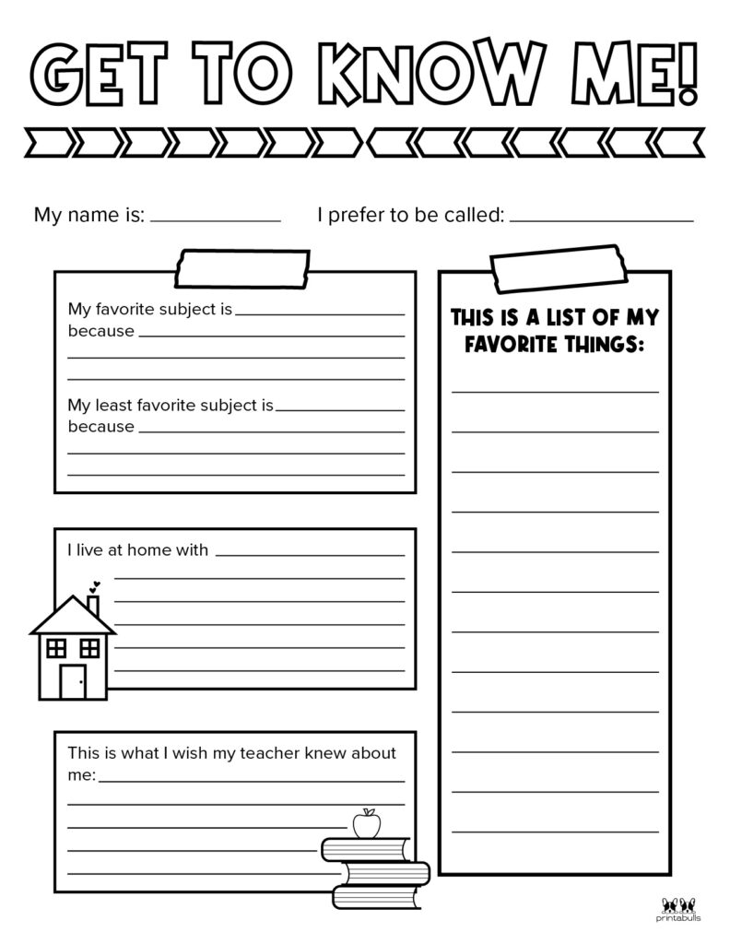
Please print, complete and pass this onto your form tutor on your first day!
THIS IS A LIST OF MY FAVOURITE THINGS:

My favourite subject is
because

My least favourite subject is
because

