Joyce Frankland Academy, Newport  
Careers Education, Information, Advice and Guidance (CEIAG) Policy  
2024 – 2025  
Careers Lead: Daniel Grindrod  
Governor Link: Gareth Conduit

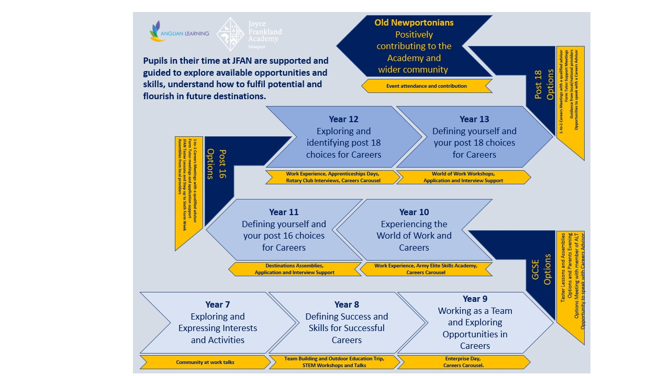  
(Image 1)

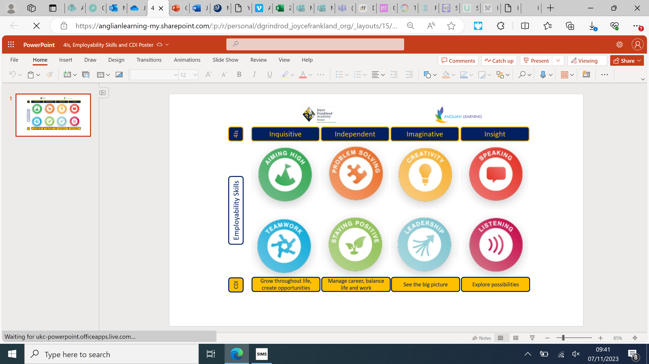  
(Image 2)

**1 Intent**

**2 Context**

**3 Entitlement**

**4 Next Steps**

**5 References**

**6 Appendices**

**1 CEIAG Intent**

***Every young person needs high-quality career guidance to make informed decisions about their future. Good career guidance is a necessity for social mobility: those young people without significant social capital or home support to draw upon have the most to gain from high-quality career guidance. (***[***www.gatsby.org.uk***](http://www.gatsby.org.uk)***)***

***Students in their time at JFAN are supported and guided to explore available opportunities and skills, understand how to fulfil potential and flourish in future destinations.***

Our intent at Joyce Frankland Academy, is to provide a broad, balanced careers curriculum, which embraces our core beliefs of; **Explore, Fulfil, Flourish,** and which provides the deep knowledge and understanding needed to allow all students to develop into **independent, inquisitive, imaginative** and **insightful** citizens, achieved through the use of the **Employability Skills Builder Program**, who contribute positively to their communities.

Careers Education, Information, Advice and Guidance (CEIAG) is an essential element of the Personal Development support given to all pupils at Joyce Frankland Academy, enabling them to prepare for the choices, challenges and opportunities that arise at each stage of their development. KS4 and KS5 one-to-one CEIAG meetings taking place with an independent Level 6+ qualified advisor from Form the Future. This is planned for and delivered in key phases of their time at JFAN, with the meetings being personalised according to their circumstances.

In setting out to achieve our aims alongside a reflective, evaluative and aspirational 3 year Careers development plan and a 7 year mapped curriculum plan, Joyce Frankland Academy uses the Gatsby Charitable Foundation’s Benchmarks to track, develop and improve the school’s careers provision. The Academy recognises that revised statutory guidance is structured around these benchmarks and that by adopting them we can be confident that we are fulfilling our legal duties. In addition to this, we work alongside the Careers Development Institute to build on their guidance of ‘I can’ statements by the end of KS3, KS4 and KS5.

|  |  |
| --- | --- |
| **The eight Gatsby benchmarks of Good Career Guidance are:** | **The six areas of the CDI Framework are:** |
| 1. A stable careers programme | 1. Grow throughout life |
| 2. Learning from career and labour market information | 2. Explore possibilities |
| 3. Addressing the needs of each pupil | 3. Manage career |
| 4. Linking curriculum learning to careers | 4. Create opportunities |
| 5. Encounters with employers and employees | 5. Balance life and work |
| 6. Experiences of workplaces | 6. See the big picture |
| 7. Encounters with further and higher education |  |
| 8. Personal guidance |  |

**2 Context**

Joyce Frankland Academy, Newport is a member of the Greater Essex Careers Hub, seeking external support and guidance from the network that this creates. JFAN is a smaller than the average-sized secondary school. Most of our students are from a White British background and very few speak English as an additional language. The proportion of pupils supported by the pupil premium is below average, as is the proportion of students who have special educational needs or a disability. The proportion of students who enter or leave the school other than at the normal times is above average. There is an important element of students within the school that come to us from the local barracks.

The local employment data (see Appendix 1), for **Uttlesford District** is illustrative of the socio-economic features of our locality. Such data is considered in the provision of our Careers guidance, although it is recognised that many in the population travel regularly to larger cosmopolitan areas such as London or Cambridge for employment.

As can be seen from local employment data, very many of the local employment opportunities stem from a variety of small to medium size businesses in a variety of different fields. It is further noted from the data that there is a burgeoning care and retail element, employment groups 6-7, these factors are taken into consideration as an over-arching part of whole school policy.

A more comprehensive break down of local employment by industry is available in Appendix 1.

**Ambitions for our students**

Preparing our students for success in life beyond Joyce Frankland Academy is our main ambition. Our Careers policy is therefore central to what we do in this aspect. All members of staff have a key part to play in this. Students see us at work every day, so we are their most significant role models as to how to act in the workplace. An essential starting point for us all, therefore, is to maintain high professional standards of dress, conduct and work.

All staff at Joyce Frankland Academy play a role in providing guidance to students, in their capacity as form tutor, professional services staff, subject teacher, Head of Year or Senior Leader. All subject areas and co-curricular activities help to prepare students in some way for the working world, whether that is through developing their use of the 4Is and the underpinning employability skills or by meeting employers (both in school, on trips and visits and during Work Experience).

**We strive to:**

Prepare our students for the choices, challenges, responsibilities and opportunities of work, including both the emergent and currently dominant industries locally.

We encourage our students to explore local employment opportunities and we strive to offer the students an insight in to emerging employment opportunities.

Enable students to fulfil their potential here, and encourage them to aim high in their careers with their post 14, post-16 and post-18 choices.

Empower students to make informed choices and to plan and manage their own career progression so that they go on and flourish.

Senior members of staff meet with students at key transition points to discuss the options available and implications of the different choices that could be made. We also host a range of parents’ information evenings from Years 9 to 13, and keep parents up to date with work related learning news and events via e-mail and on our website. We also have specific Careers focus display boards for parents to engage with during year group parents evenings. We empower students, and their parent/carers, to make important decisions more independently because they receive current information.

Students who join our school, at key transition points or otherwise, are individually given an interview that is intended to offer information, advice and guidance so that careful reflection and consideration of choices is evident.

**3 Entitlement**

**Explicit Delivery of the Programme/Overview of Provision**

We strive at Joyce Frankland Academy, Newport to ensure that all pupils have a minimum entitlement of “one a day, one a week, one a term” Careers experience that is outlined in the year specific documentation. Over the course of a pupils time at JFAN they will experience the minimum of the following through both the Careers Provision and Personal Development goals

* A standalone curriculum that focuses on Employability Skills, highlighting their benefit in all aspects of the curriculum
* An interaction with the world of work from an external employee in every year
* Information regarding options and destinations from more than two providers at each key phase to meet the Provider Access Legislation
* A one-to-one meeting with a level 6+ qualified careers advisor in Year 10/11 and the opportunity for another meeting in Year 12/13
* An experience of the workplace in Year 10 and Year 12
* The opportunity to attend lunchtime and after school clubs each year to develop rounded skills

Curriculum time is explicitly dedicated to Careers. Careers lessons comprise a key part of the PSHE and tutorial programme from Years 7 to 13 (please see Appendix B for further detail), focusing on the Employability Skills, increasing Careers understanding, broadening horizons and challenging stereotypes. Lessons are also supplemented by visits from local employers, employees and education providers within the context of curriculum and super-curricular opportunities. Through all these sessions, students learn about different career paths and the local employment scene, gain an understanding of the skills required in the modern workplace and reflect on their own personal skills, both in terms of what they currently possess and what they need to develop. Alongside the explicit Careers curriculum, the skills for successful careers are implicitly delivered in lesson through the 4Is.

An additional aspect of our provision is through signposting, use of on-line platforms, mainly Unifrog, and resources that have been created to support our students. Time is dedicated, in school and at home, to the use of these and students regularly research and consider the resources that staff have signposted to them through the school website.

Furthermore, students are supported with independent, personalised guidance at each key phase in their education and career progression, including: a meeting with a member of the senior leadership team during their GCSE choices in Year 9, a meeting with a Level 6 trained careers advisor during Year 10/11 to support their post 16 choices and are offered a meeting with a Level 6 trained careers advisor during Year 12/13 to support their post 18 choices.

The careers education we provide has been developed in consideration of the Gatsby Report’s benchmarks, the CDI (Career Development Institute) Framework for careers, employability and enterprise education 7-19. Our programme is developmental with activities in each year building on and deepening students’ understanding of what has been learnt in previous years. We take an evaluative approach with our outcomes being impact led.

It is recognised that our programme must regularly develop and evolve to match both current and future employment skill needs. The CEAIG Programme, of which Careers provision is a sub-set, is subject to annual review and development.

Tracking the meaningful encounters that each student experiences is underway across the school. The current entitlement is that each student have at least one meaningful encounter per year in relation to Careers/WRLE and this will be logged via their Unifrog log in (please see Appendix C for further detail on these encounters). These meaningful encounters do not include the aim that providers have multiple opportunities, with the minimum being two per phase (Year 8-9/Year 10-11 and the opportunity in Year12/13) to speak to students and their parents across Years 7 -13 to offer information on vocational, technical and apprenticeship qualifications and pathways. These meaningful encounters are planned to achieve the four key points below to abide by the 2023 updated Provider Access Legislation:

* Information about the provider and the approved technical education qualifications or apprenticeships that the provider offers
* Information about the careers to which those technical education qualifications or apprenticeships might lead
* A description of what learning or training with the provider is like
* Responses to questions from the pupils about the provider or approved technical education qualifications and apprenticeships.

More on this is outlined in the Provider Access/Baker Clause Policy Statement which can be found on our website.

Our Work Experience programme at Joyce Frankland Academy, Newport takes place in the summer term with pupils identifying and researching placements as well as the option of choosing from a catalogue of placement offers alongside identifying their own. More on this is outlined in our Work Experience Policy which can be found on our website.

**4. Next Steps**

Our Next Steps are identified through evaluation processes that include:

* Compass+ Tool and Unifrog interaction reviews
* Student feedback based on the CDI ‘Can do’ statements
* Parent feedback
* Employer/provider feedback
* Staff feedback

These five areas of evaluation help to shape the future careers provision, identifying areas of strength and development. Two elements that have been identified are:

* Review the impact of our careers policy and provision using Compass+ Tool
* Building on the action plan meetings that form our membership in the Greater Essex Careers Hub

**References**:

Gatsby Benchmarks:

<http://www.gatsby.org.uk>

Local Employment Data:

[District Labour Market Posters - Greater Essex Careers Hub](https://greateressexcareershub.co.uk/hub-resources/gech-resources/district-labour-market-posters/)

**Appendices:**

Appendix A - Local employment data

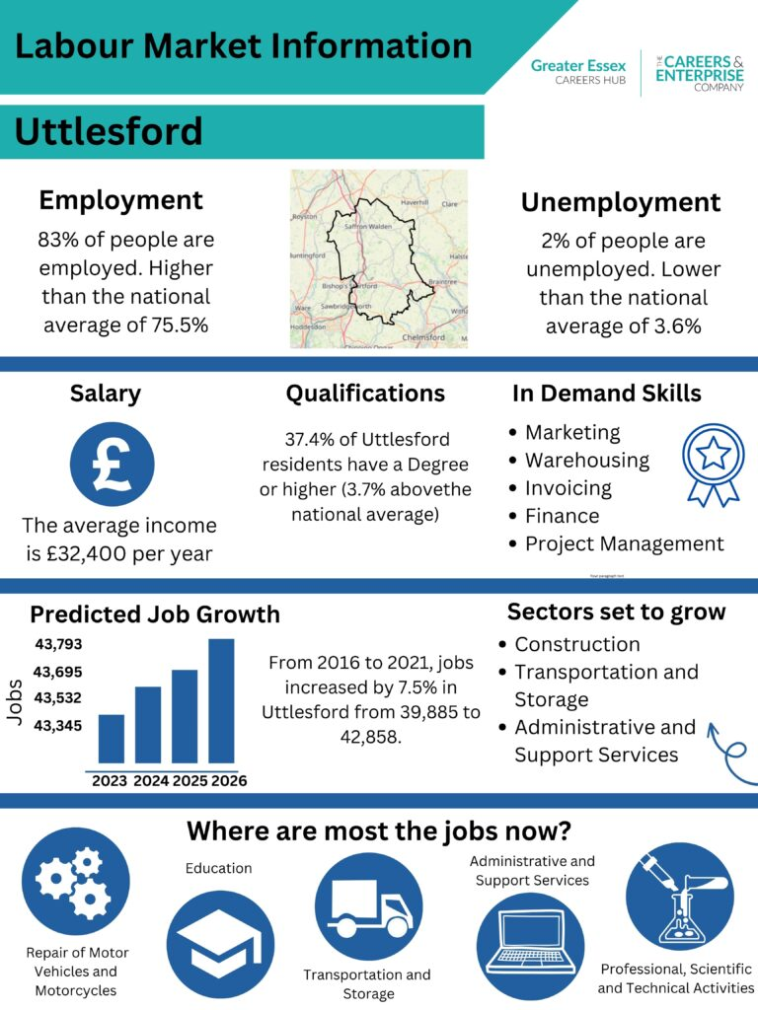

Appendix B – Yearly Plan:

*Our year plan is consistently updated. On page one of this document you can see the flow diagram of the focus points for each year group. If you wish to view an up to date copy of the year plan, please contact* [*dgrindrod@joycefrankland.org*](mailto:dgrindrod@joycefrankland.org)

Appendix C – Examples of the meaningful encounters at JFAN

**Contact With the World of Work**

**In the Curriculum**

|  |  |  |
| --- | --- | --- |
| Activity | Impact | Evidence |
| Weekly Careers Sessions during form time | Students gain an understanding of the importance of Careers as a process, with a variety of specific sessions at key parts of their experience at JFAN. | Year Plan  Gatsby 1 CDI 1-6 |
| Marking policy – personal development via identified strengths/targets, green pen response, Challenge Checkpoints, personalised feedback and RAG tracking | Students gain an understanding of their strengths and areas for improvement; they are encouraged to reflect on their own performance. | Work scrutiny within Faculties  Student questionnaire comments  Staff feedback via questionnaire.  Gatsby 3, 4, 8 CDI 1, 3 |
| Curriculum | Students develop employability skills, highlighted as the 4Is, through tasks completed in class; students learn about specific careers related to their subjects | Work scrutiny within Faculties  Staff feedback via questionnaire  Careers Week Gatsby 1, 2, 3, 4,  CDI 1 - 6 |
| Leadership opportunities across the Academy | Students are able to be trained, model, and to develop, leadership skills that are transferable in to the world of work. | Student feedback.  Unifrog Interactions.  Gatsby 3, 4  CDI 1, 3, 4, 5 |
| STEM related activities within Science and Technology | Students gain understanding of STEM related careers during lessons, including further opportunities for students through extra-curricular club attendance and the specific STEM day in Year 8, thus opening up choices for the future. | Student feedback, student participation rates.  Unifrog Interactions.  Gatsby 4  CDI 1, 2, 3, 4 |
| Careers related signage, including local employment data and discussion of transferable skills on the school website, subject specific posters, Unifrog and via visits. | Students are able to see, and link, how subjects relate to potential future employment opportunities.  Local employment data helps to inform student option choices in relation to emergent and dominant local industries. | Student feedback  Scrutiny  Unifrog Interactions.  Gatsby 1, 2, 4  CDI 2, 3, 6 |
| Subject links with local businesses and through visits or trips are encouraged as part of their curriculum. | Students see how what they are studying in class relates to the world of work | Student feedback  Unifrog Interactions.  Careers Week  Trip evaluation forms  Trip rationale forms  Gatsby 4, 5, 6  CDI 2, 6 |

**Experience of the Workplace**

|  |  |  |
| --- | --- | --- |
| Activity | Impact | Evidence |
| Subject Trips and Talks | Subjects are encouraged to take students on trips to experience workplaces relevant to their curriculum. | Trip rationale forms Trip evaluation forms  Gatsby 2, 4, 5, 6  CDI 1, 2, 3, 4, 5, 6 |
| Student events | Students complete a task set by an external employer/employee and receive feedback on the completion of this task. | Year group specific careers days  Gatsby 6  CDI 1, 2, 3, 4, 5, 6 |
| Work experience | Students complete work related tasks in the work place or virtually that mirror those of an employer/employee. Students receive feedback on these. | Year 10 and 12 Work Experience Gatsby 6 CDI 1, 2, 3, 4, 5, 6 |

**Parental/Local Community Involvement and representatives from the world of work**

|  |  |  |
| --- | --- | --- |
| Activity | Impact | Evidence |
| Subject specific visits | Representatives from local companies deliver talks and QA sessions; students gain an understanding of different jobs, the skills and the qualifications required to do them | Student feedback  Visitor feedback  Unifrog Interactions.  Curriculum plans  Records of student attendance, tracking  Gatsby 2, 4, 5, 6  CDI 1 - 6 |
| Parent/Carer/Ex-Student involvement | Parents/Carers/Ex-Students attend year group specific sessions to share their experiences and expertise. This includes the year group summer Careers sessions, Careers Week sessions and curriculum time too. | Student feedback  Visitor feedback  Unifrog Interactions.  Curriculum plans  Records of student attendance, tracking  Gatsby 2, 4, 5, 6  CDI 1 - 6 |
| Year 7 – Our community at work | Parents/Carers/Ex-Students attend year group specific sessions to share their experiences and expertise. | Student feedback  Visitor feedback  Unifrog Interactions.  Curriculum plans  Records of student attendance, tracking  Gatsby 2, 4, 5, 6  CDI 1 - 6 |
| Year 8 – STEM workshops | Local STEM Businesses, Employers and Employees host workshops for students, sharing their experiences and expertise. | Student feedback  Visitor feedback  Unifrog Interactions.  Curriculum plans  Records of student attendance, tracking  Gatsby 2, 4, 5, 6  CDI 1 - 6 |
| Year 9 – Enterprise Day | Students work with local entrepreneurs to create and pitch a business idea. They develop their employability skills in a real world setting, receiving targeted and individual feedback during the day | Student feedback  Visitor feedback  Unifrog Interactions.  Curriculum plans  Records of student attendance, tracking  Gatsby 2, 4, 5, 6  CDI 1 - 6 |
| Year 10 – Elite Skills Academy | The Army Outreach Team deliver sessions for students to work on the skills that make them an elite force. | Student feedback  Visitor feedback  Unifrog Interactions.  Curriculum plans  Records of student attendance, tracking  Gatsby 2, 4, 5, 6  CDI 1 - 6 |
| Year 9/10/12 - Careers Fair | Students receive presentations from local providers, employers and employees | Student feedback  Visitor feedback  Unifrog Interactions.  Curriculum plans  Records of student attendance, tracking  Gatsby 2, 4, 5, 6  CDI 1 - 6 |
| Year 10/12 Work Experience | Students complete work related tasks in the work place or virtually that mirror those of an employer/employee. Students receive feedback on these. | Year 10 and 12 Work Experience Gatsby 6 CDI 1, 2, 3, 4, 5, 6 |
| Year 12 and 13 – Business Speed Dating | Students have sessions to ask employers/employees/businesses about their careers and opportunities. Students also complete a task set by an employer, receiving individual feedback during the session. | Student feedback  Visitor feedback  Unifrog Interactions.  Curriculum plans  Records of student attendance, tracking  Gatsby 2, 4, 5, 6  CDI 1 - 6 |

**Information and Guidance Meetings**

|  |  |  |
| --- | --- | --- |
| Activity | Impact/Amplification | Evidence |
| Post 16 Guidance meetings | Members of the year group form team have meetings with students to discuss their choices and provide advice; students are supported to make informed choices. Students that require further support if they are deemed to be at risk of NEET are referred to the HoY for further support and 1-to-1 meetings | Unifrog Interactions.  Student feedback  Staff feedback  Gatsby 3,8 CDI 1-6 |
| Year 10/11 Guidance meetings | Students meet with a Level 6+ trained advisor to discuss their career pathways. | Unifrog interactions  Student feedback  Action plans  Advisor feedback  GB 3,8  CDI 1,2,3,4,5,6 |
| Target group mentoring via ALT | Ensuring that all target group students plan for an appropriate progression route into GCSE, 6th Form, further or higher education, employment or apprenticeships or GAP years. | Student feedback  Unifrog Interactions.  Improved attainment  Improved attendance  Fewer  Gatsby 3, 8 CDI 1-6 |
| Rotary Club Mock Interviews | Students gain interview IAG as well as guidance regarding potential local career paths. | Student feedback  Unifrog Interactions.  Visitor feedback  Records of student attendance, tracking  Gatsby 2, 3, 5 |
| Post 18 Guidance meetings | Members of the year group form team have meetings with students to discuss their choices and provide advice; students are supported to make informed choices. Students that require further support if they are deemed to be at risk of NEET are referred to the HoY for further support and 1-to-1 meetings | Unifrog Interactions.  Gatsby 3,8 CDI 1-6 |
| Year 12/13 Guidance meetings | Students are offered the opportunity to meet with a Level 6+ trained advisor to discuss their career pathways. | Unifrog ineractions  Student feedback  Action plans  Advisor feedback  GB 3,8  CDI 1,2,3,4,5,6 |

**Approval and review**

Approved [date] by Governors at Curriculum and Standards Committee

Next review: September 2026

Signed:

Chair of Governors

Head teacher